
DEPARTMENT OF ELECTRONICS AND COMMUNICATION ENGINEERING


SJB INSTITUTE OF TECHNOLOGY
#67,B G S HEALTH AND EDUCATION CITY


Kengeri, Bengaluru-560 060.

VISVESVARAYA TECHNOLOGICAL UNIVERSITY
“JNANA SANGAMA”, BELAGAVI-590 018.


2022 – 2023
A Project Report
(Phase - I)
on

“Wireless Acoustic Data and Image Transmission Over
Handheld Transreciever (W.A.D.I.T.O.H.T)”

Submitted in partial fulfillment for the award of the degree of
BACHELOR OF ENGINEERING
in

ELECTRONICS AND COMMUNICATION ENGINEERING

Submitted By

Dinanshu Biswas [1JB19EC026]
Nivendu tripathi [1JB19EC063]
Mohammed Ashfaq [1JB19EC053]
Mohammed Atheeq Zamani [1JB19EC054]

Under the guidance of
Mrs. Supriya m
Asst. Professor
Dept. of ECE

||Jai Sri Gurudev||
Sri Adichunchanagiri Shikshana Trust ®

SJB INSTITUTE OF TECHNOLOGY

BGS Health & Education City, Kengeri, Bengaluru-560 060.

DEPARTMENT OF ELECTRONICS AND COMMUNICATION ENGINEERING

CERTIFICATE

Certified that the project work phase – I entitled “Wireless Acoustic Data and Image Transmission Over
Handheld Transceiver (W.A.D.I.T.O.H.T)” carried out by Dinanshu Biswas [1JB19EC026], Nivendu Tripathi [1JB19EC063], Mohammed Ashfaq [1JB19EC053] and Mohammed Atheeq Zamani [1JB19EC054] are bonafide student of SJB Institute of Technology in partial fulfillment for the award of “BACHELOR OF ENGINEERING” in ELECTRONICS AND COMMUNICATION ENGINEERING as prescribed by VISVESVARAYA TECHNOLOGICAL UNIVERSITY, BELAGAVI during the academic year 2022 – 23. It is certified that all corrections/suggestions indicated for internal assessment have been incorporated in the report deposited in the departmental library. The project report has been approved as it satisfies the academic requirements in respect of project work phase – I prescribed for the said degree.

Mrs. Supriya M Dr. D N Chandrappa Dr. K V Mahendra Prashanth
Guide & Asst. Professor Professor & Head Principal
Dept. of ECE, SJBIT Dept. of ECE, SJBIT SJBIT

Name of Examiners Signature with Date


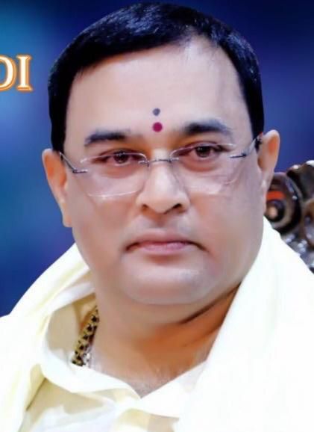

ACKNOWLEDGEMENT
We would like to express our profound gratitude to His Divine Soul Jagadguru Padmabhushan Sri Sri Sri Dr. Balagangadharanatha Mahaswamiji and His Holiness Jagadguru Sri Sri Sri Dr. Nirmalanandanatha Swamiji for providing us an opportunity to be a part of this esteemed institution.
We would also like to express our profound thanks to Revered Sri Sri Dr. Prakashnath Swamiji, Managing Director, SJB Institute of Technology, for his continuous support in providing amenities to carry out this project (Phase – I) in this admired institution.
We express our gratitude to Dr. K V Mahendra Prashanth, Principal, SJB Institute of Technology, for providing us with excellent facilities and academic ambiance, which helped us in the satisfactory completion of project work (Phase – I).
We extend our sincere thanks to Dr. D N Chandrappa, Professor & Head, Department of ECE; for providing us invaluable support throughout the period of our project work (Phase – I).
We wish to express our heartfelt gratitude to our guide, Mrs. Supriya M, Asst. Professor for his valuable guidance, suggestions, and encouragement during the entire period of our project work (Phase – I).
We express our truthful thanks to Dr. Mahantesh K, and Mr. Bhaskar B, project coordinators, Dept. of Electronics and Communication for their valuable support.
Finally, I take this opportunity to extend my earnest gratitude and respect to our parents, the teaching & technical staff of the department, the library staff, and all my friends, who have directly or indirectly supported me during the period of my project work (Phase – I).

Regards,
Dinanshu Biswas [1JB19EC026]
Nivendu Tripathi [1JB19EC063]
Mohammed Ashfaq [1JB19EC053]
Mohammed Atheeq Zamani [1JB19EC054]

DECLARATION

We hereby declare that the entire work embodied in this project report has been carried out under the supervision of Mr. Bhaskar B, Asst. Professor in partial fulfillment for the award of “BACHELOR OF ENGINEERING” in ELECTRONICS AND COMMUNICATION ENGINEERING as prescribed by VISVESVARAYA TECHNOLOGICAL UNIVERSITY, BELAGAVI during the academic year 2022 – 23.

Dinanshu Biswas [1JB19EC026]
Nivendu Tripathi [1JB19EC063]
Mohammed Ashfaq [1JB19EC053]
Mohammed Atheeq Zamani [1JB19EC054]

ABSTRACT

The digital divide between urban and rural areas is now attracting active research. There are a host of reasons for this divide and this paper presents the work in progress about one proposed solution to a major technical problem causing this. It has been noted that the high frequency WiFi and similar signals are not well suited for the wilderness type of environment with dense foliage. Additionally, such terrains also impose stringent restriction on computational and electric power as well as in cost. This calls forth the need for a new type of signal that can work efficiently in such environments and a low cost, low bandwidth, low frequency signal that can possibly work is identified in the form of Sound. This paper presents a new network architecture that is designed to work with the low frequency, ubiquitous signals such as sound. The architecture can work in peer-to-peer ad-hoc networks mode, infrastructure mode, broadcast mode (for remote telemetry) etc. using wideband multi-channel transmission. However, since the proposed architecture uses low frequency signal, it is expected to deliver low throughput as well. Using a ubiquitous signal such as sound makes the entire process very cost effective as it eliminates the need of expensive transceivers.
Even in these days where data networks have increased much in terms of speed, bandwidth and penetration, the need for a low power, low bandwidth, ubiquitous networks is more pronounced than ever before. As the devices get smaller, their power supply is also limited, in according to the definition of “dust”, “skin” and “clay” in the ubiquitous computing paradigm. The possibility of these devices to be present in real world depends a lot on the key capability they must possess, which is to be network enabled, ubiquitously. This paper looks at the possibility of using the ever-present signal “sound” as a ubiquitous medium of communication. We are currently experimenting on various possibilities and protocols that can make use of sound for text transmission between two electronic devices and this paper looks at some attempts in this direction. The initial phase of the experiment was conducted using a very large spectrum and encoding the entire ASCII text over audible sound spectrum. This gave a very large spectrum spread requirement which a very narrow frequency gap. The experimental results showed good improvement when the frequency gap was increased.

.

TABLE OF CONTENTS
Chapter No. | Particulars | Page
Certificate |  | ii
Acknowledgment |  | iii
Declaration |  | iv
Abstract |  | v
Table of contents |  | vi
List of figures |  | vii
1 | INTRODUCTION | 1
2 | CHALLENGES, MOTIVATION & OBJECTIVES  - MOTIVATION AND CHALLENGES  - OBJECTIVES | 2
3 | LITERATURE SURVEY | 3
4 | HARDWARE & SOFTWARE REQUIREMENTS  4.1 HARDWARE REQUIREMENTS  4.2 SOFTWARE REQUIREMENTS | 5
5 | PROPOSED METHODOLOGY  5.1 BLOCK DIAGRAM  5.2 EXPECTED OUTCOME  5.3 APPLICATIONS | 10
6 | CONCLUSION | 12
REFERENCES |  | 13

LIST OF FIGURES
Figure No. | Particulars | Page No.
1 | Raspberry pi bottom | 5
2 | Raspberry pi top | 5
3 | Transmitter | 6
4 | Reciever | 7
5 | A/D | 7
6 | 5V power supply | 8
7 | Polylactic Acid (PLA) filament | 8
8 | Raspberry Pi Logo | 9
9 | Python Programming Language Logo | 9
10 | Block Diagram | 11

LIST OF ABBREVIATIONS

- HT- Handheld Transreciever
- SSTV- slow scan television
- ARPS - Automatic Packet Reporting System
- USSB - Ubiquitous Signal,Sonic Barcode

CHAPTER 1

INTRODUCTION
Digital signal processing (DSP) in user space on an off-the-shelf workstation (a PC in our case). These devices are very different from programmable digital radios using application specific digital hardware or digital signal processors (DSP's) under software control. They represent, to our knowledge, the first implementation of a software radio which digitizes a wideband (e.g., 10 MHz) of the RF spectrum and performs all the signal processing in application-level software using a general-purpose processor.
The Spectrum where project is devoted to building infra structure to support the construction of virtual radios and to building virtual radios that take advantage of the resources available on the workstation to either provide distinctive functionality or to implement traditional functionality in a distinctive way.

Acoustic systems (AC-Acoustic Communication) are either passive, in that they exploit the acoustic noise radiated by a source (its so-called sound signature), or active, where they insanity the target and process the echo information. War fighters use a variety of sensing technologies for reconnaissance, intelligence, and surveillance of the battle space. The sensor outputs are processed to extract tactical information on sources of military interest.
The processing reveals the presence of sources (detection process) in the area of operations, their identities (classification or recognition), locations (localization), and their movement histories through the battle space (tracking). This information is used to compile the common operating picture for input to the intelligence and command decision processes.

Chirping communication (CC) uses sound waves rather than radio waves, the technology offers a convenient approach to transferring data, and can be integrated into many existing devices, as it only requires a speaker in the sending device, along with a microphone and a small amount of processing power in the receiving device. Chirp’s technology offers many advantages over Wi-Fi and Bluetooth, as the setup and pairing processes are removed, and sound can be immediately broadcast to nearby receiving devices.
Using sound has been a powerful way of communicating data since the earliest days of telecommunications, from telegraphs and Morse code to dial-up modems. The difference is that we have developed algorithms that work “over the air”, in noisy and acoustically challenging environments.

Spatial modulation (SM) scheme has been developed as a hopeful candidate for spectral and energy-efficient wireless communication systems, as it provides a great judgment for the system performance, data transmission rate, receiver complexity, and energy/spectrum efficiency. In SM, the data is conveyed by both habitual M-Ary signal constellations and the transmit antennas indices. Therefore, the system data rate improvement due to the side information bits transmitted, encapsulated in indices of the transmit antennas, improves the SM transmission efficiency compared to the different MIMO players.

CHAPTER 2

CHALLENGES, MOTIVATION AND OBJECTIVES

2.1 MOTIVATION AND CHALLENGES

- Communication systems have been developed using communication medium such as radio frequency (RF) or Infrared (IR) to transmit data. However, these systems require specialized communication hardware and/or interfaces, which can often be expensive and/or impractical to implement. write a line of text in a straight line on white paper which makes the recognition of text difficult. Segmentation of fields in a blue book using pre-existing templates.

- Only 64x64 pixel image can be converted to sound, any higher or lower it creates interference with intended application.

- The project has an immense potential in military applications from data communication (text, audio, image, video) without internet to industrial production setups to sensing of foreign aliens.

2.2 OBJECTIVES

- Images, text and audio are transmitted on sound waves in wireless comms architecture.

- Images are converted to sound and make them non detectable to sensors.

- Network sniffing and packet tracing is not detected in the case of sound waves to ensure a secure transmission of data.

- To encode, encrypt and emit the data (text, audio, image, video) over handheld trans receiver’s

- To represent the converted data on a spreadsheet or store it for future use.

CHAPTER 3

LITERATURE SURVEY

[1] Chirping Communication – Sending Data Over Sound | Dr Daniel Jones

This paper presents a novel technique for designing a sound based networking infrastructure, to provide an alternative to wireless RF comms protocol.
.

[2] Underwater Image Transmission Using Spatial Modulation Unequal Error Protection for Internet of Underwater Things | Dr. Hamada Esmaiel Junfeng Wang, Naveed Ur Rehman and Zeyad A. H. Qasem

The objective of the paper is to provide an algorithm for encoded image classification and performing the next generation of the underwater acoustic communication techniques that would be focused on improving transmission data rate to support real-time underwater multimedia applications.

[3] Ubiquitous Text Transfer Using Sound a Zero-Infrastructure Alternative for Simple Text Communication | Kuruvilla Mathew, Biju Issac and Tan Chong

This paper shows conventional software radios take advantage of vastly improved analog to digital converters (ADC’s) and digital signal processing (DSP) hardware. This paper approaches, with what they refer to as virtual radios, rather than use DSP’s, they have chosen to ride the curve of rapidly improving workstation hardware. Use of wideband digitization and then perform all of the digital signal processing in user space on a general purpose workstation. This approach provides new way to signal processing that exploit the hardware and software resources of the workstation.

[4] Review on design and fabrication Virtual Radios | Vanu Bose, Michael Ismert, Matt Welborn, and John Guttag

This paper deals with the design and fabrication of end effectors of robot to perform pick and place activities. For material handling in industries robot with special-purpose end effectors plays a great role to reduce cycle time and cost of production. The design of the gripper is propelled by the requirement for grasping of sheet metal parts in the stamping and fording industry. The design has focused on provincial general-purpose grippers having kinematic and dexterousness similar to human hand (humanoid).

[5] A digital image processing system for slow scan television | James Schueckler

In the paper "A digital image processing system for slow scan television" by James Schueckler, the author presents a digital image processing system for improving the quality of images transmitted using the slow scan television method. The system involves hardware and software components that work together to enhance the resolution and quality of the images. The system uses an analog-to-digital converter to convert the analog signal from the SSTV transmitter to a digital format. The digital signal is then processed using a custom-designed software program that implements various image processing techniques. The software program includes algorithms for image compression, noise reduction, contrast enhancement, and image sharpening. The paper also provides experimental results that demonstrate the effectiveness of the proposed system in improving the quality of slow scan television transmissions. The author conducted tests using a slow scan television system to transmit images over a radio frequency, and then processed the received images using the proposed system. The results show that the system was able to improve the resolution, contrast, and overall quality of the transmitted images. Overall, the proposed digital image processing system represents a significant improvement over traditional slow scan television systems, which often suffer from low image quality and resolution. With the use of this system, slow scan television transmissions can be greatly improved, making them more useful for a variety of applications such as remote sensing, surveillance, and amateur radio.

[6] Acoustic signal processing for enhanced situational awareness during military operations on land and under the sea | Brian G. Ferguson

It can be inferred that the paper describes a system for processing acoustic signals to enhance situational awareness during military operations. The system is likely to involve advanced acoustic signal processing techniques that can detect, identify, and locate sound sources, and provide relevant information to the military personnel in real-time. The paper may also discuss the hardware and software components used in the system, and the experimental results to demonstrate the effectiveness of the proposed system in enhancing situational awareness. Finally, the paper may explore potential applications of the proposed system, both on land and under the sea, for military operations, intelligence gathering, and security purposes. The system involves a variety of advanced acoustic signal processing techniques, including time-domain and frequency-domain analysis, beamforming, and source localization. These techniques allow the system to detect, identify, and locate sound sources in real-time, providing valuable information to military personnel in the field. For example, the system can identify the sound of an approaching vehicle or the direction of gunfire.

The paper also discusses the hardware and software components used in the system. The hardware includes sensors, microphones, and other acoustic devices that can capture sound signals, as well as the processing unit, which can be a computer or other specialized device. The software includes the algorithms and programs used to process the acoustic signals and extract relevant information.

The paper provides experimental results that demonstrate the effectiveness of the proposed system in enhancing situational awareness. The author conducted tests in both land and underwater environments, and the results show that the system was able to accurately detect and locate sound sources, even in noisy or complex environments.

Finally, the paper explores potential applications of the proposed system for military operations, intelligence gathering, and security purposes. For example, the system can be used to detect and locate hostile forces or identify and track the movement of friendly forces. It can also be used in intelligence gathering operations, such as monitoring the movements of ships or submarines. Overall, the proposed system represents a significant advance in the field of acoustic signal processing and has the potential to greatly enhance situational awareness during military operations on land and under the sea.
.

CHAPTER 4

HARDWARE AND SOFTWARE REQUIREMENTS

  - HARDWARE REQUIREMENTS

    - Raspberry Pi Model 2B

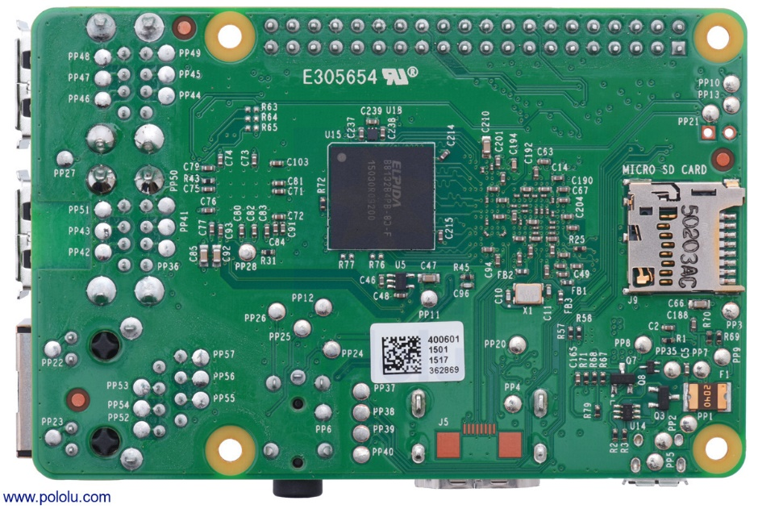
Figure 1- Raspberry pi bottom

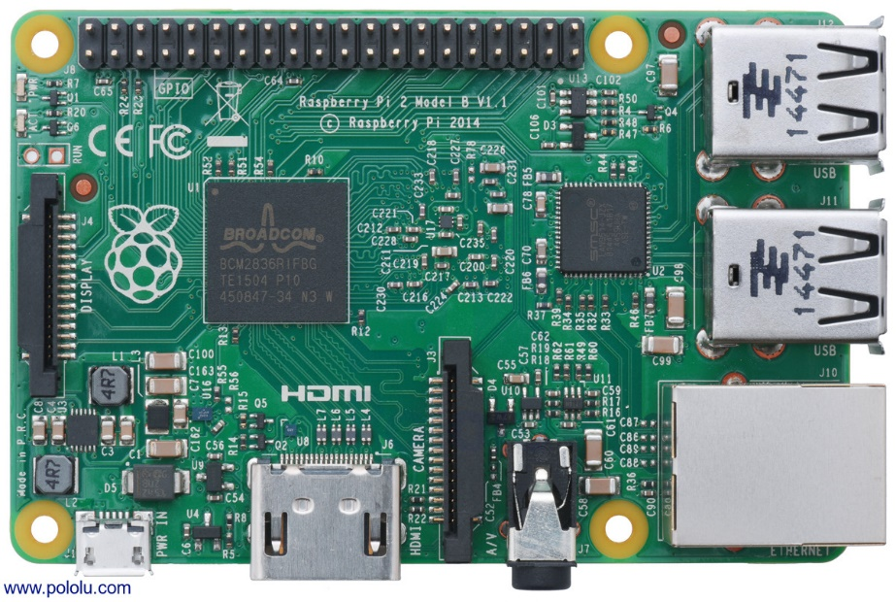
Figure 2- Raspberry pi top

The Raspberry Pi 2 Model B is the second-generation Raspberry Pi. It replaced the original Raspberry Pi 1 Model B+ in February 2015.
- A 900MHz quad-core ARM Cortex-A7 CPU
- 1GB RAM
- 100 Base Ethernet
- 4 USB ports
- 40 GPIO pins
- Full HDMI port
- Combined 3.5mm audio jack and composite video
- Camera interface (CSI)
- Display interface (DSI)
- Micro SD card slot
- Video Core IV 3D graphics core

The Raspberry Pi is a credit card-sized computer. The Raspberry Pi 2 Model B is the second-generation Raspberry Pi. It is based on the BCM2836 system-on-chip (SoC), which includes a quad-core ARM Cortex-A7 processor and a powerful GPU. The Raspberry Pi supports various distributions of Linux including Debian, Fedora, and Arch Linux. The Raspberry Pi was designed by the Raspberry Pi Foundation in order to provide an affordable platform for experimentation and education in computer programming. The Raspberry Pi can be used for many of the things that a normal desktop PC does, including word processing, spreadsheets, high-definition video, games, and programming. USB devices such as keyboards and mice can be connected via the board’s four USB ports. Over five million Raspberry Pis have been sold, and lots of resources for the Raspberry Pi are available online. The Raspberry Pi 2 Model B has the same form factor and connector locations as the older Raspberry Pi Model B+ and the newer Raspberry Pi 3 Model B. It has an ARMv7 processor, which means it can run the full range of ARM GNU/Linux distributions, including Snappy Ubuntu Core, as well as Microsoft Windows 10. With its 0.1″-spaced GPIO header and small size, the Raspberry Pi also works as a programmable controller in a wide variety of robotics and electronics applications.

    - 5V Power Supply

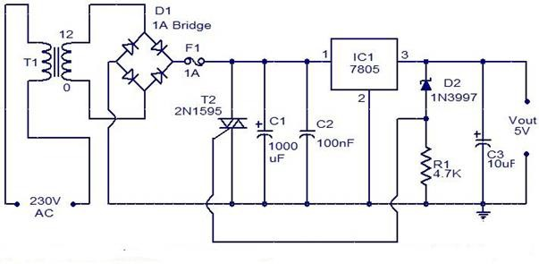
Figure 6- 5V power supply

The transformer 230Volts will be stepped down to 12-0-12 one side of the 12V is given to the 7805 and LM317. In this project, the microcontroller requires a +5V power supply. The design description of the power supply is given below. The +5 Volt and 3.8V power supply are based on the commercial 7805 & LM317 voltage regulator IC. This IC contains all the circuitry needed to accept any input voltage from 8 to 18 volts and produce a steady +5 volt & 3.8 volt output, accurate to within 5% (0.25 volt). It also contains current-limiting circuitry and thermal overload protection, so that the IC won't be damaged in case of excessive load current; it will reduce its output voltage instead. The 1000µf capacitor serves as a "reservoir" that maintains a reasonable input voltage to the 7805 throughout the entire cycle of the ac line voltage. The bridge rectifier (WM04) keeps recharging the reservoir capacitor on alternate half-cycles of the line voltage, and the capacitor is quite capable of sustaining any reasonable load in between charging pulses. The LED and its series resistor (220ohm) serve as a pilot light to indicate when the power supply is on and also help the reservoir capacitor to be completely discharged after power is turned off.

    - Polylactic Acid (PLA) filament

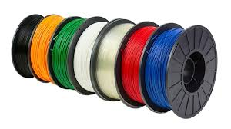
Figure 7- Polylactic Acid (PLA) filament

Polylactic Acid (PLA) filament is a recyclable, natural thermoplastic polyester that is derived from renewable resources such as corn starch or sugar cane. The filament is biodegradable under certain conditions with high heat capacity and high mechanical strength. It can be melted without significant damage and does not emit toxins or fumes. PLA is an easy-to-use material for many who are just starting their 3D printing journey. It can be printed at low temperatures, does not require heated beds or environmentally controlled build chambers, and can be purchased in filament form at a low cost.

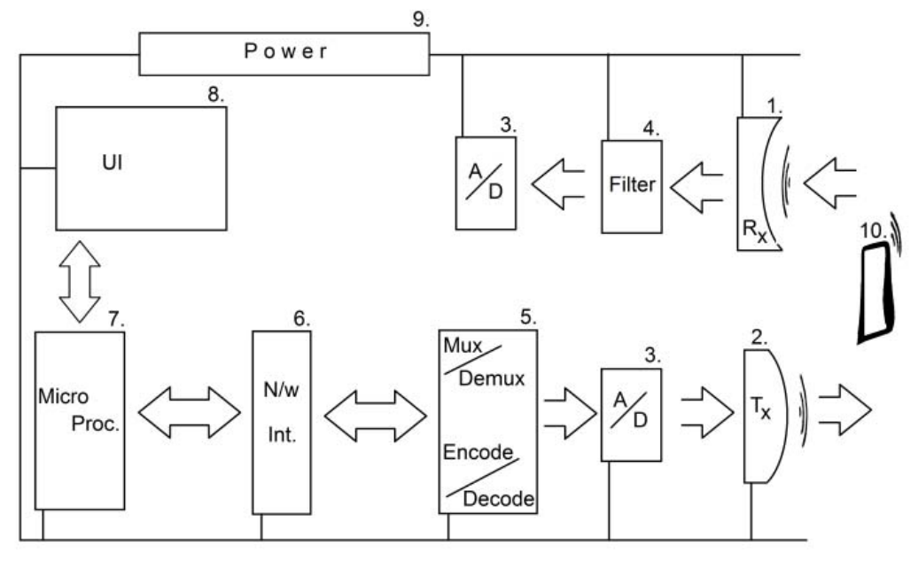

    - Transmitter

The transmitter is the low energy, low frequency signal generator. This is an analog device that is responsible for converting the electrical signal from the A/D to the transmission signal. In our consideration, we look at sound as a possible signal, in which case the transmitter is a simple that can generate signals of the specific frequency used by the system.

    - Reciever

The receiver is responsible for receiving the signal sent out by the transmitter and convert it into electrical signals. This device is an analog device, which is capable of receiving analog signals and converting them into analog electrical signals. When considering sound as the network signal, a simple microphone that can respond to the specific transmission frequencies can act as the receiver.

    - A/D

The actual signal being transmitted may be analog. This obviously calls for the need of an Analog to Digital Converter. This device is responsible for converting the digital pulses to analog electrical signals that can be handled by the transmitter and also to translate the analog signals read by the receiver into corresponding digital pulses. The ADC will work before the actual signal transmission in the case of sending data and after the filter in the case of receiving data.

    - Filter

The signal is expected to use a frequency band from a wide spectrum of available frequencies. Hence, for efficiency, it is desirous that the unwanted frequencies are filtered out since they directly translate as noise. If this noise is allowed to propagate, it will consume resources and therefore, for better efficiency and resource utilization, it is best that the noise is eliminated as early as possible in the system. Hence the noise filter is introduced soon after the signal is captured and before it is fed into the ADC.

    - MUX/DEMUX

A Multiplexer/ De-multiplexer block is responsible for decoding the data encoded in the signal. In the transmission process, the MUX will receive the data from the network interface, generate the audio signal, and encode the signal using the agreed protocols. In the reception process, the DEMUX will receive the digital signal from the ADC and use the same protocols applied during the signal encoding and extract the data from the signal, which is passed on to the network interface for further processing.

    - N/W Interface

This simplified interface module block is responsible for acting as the intermediate between the transmission device and the signal transmission and reception mechanism. The block also allow for modularity of the system design, allowing interoperability between different signaling methods and allow the higher levels to integrate seamlessly with different possible signal types that may evolve in future. For the scope of the current study, we will look at one such possible signal, sound. If the transmission mechanism for the terrain is found to perform better using light instead of sound, this block will allow the communication mechanism to work with changing only the signaling mechanism as this layer insulates the underlying details from the users.

    - Measurement Devices

The measurement devices play an important role in this domain. Each of these devices are expected to be low-tech devices with minimal computing hardware resources and is expected to have full communication capability using this protocol. This implies that each measuring device will have full block of each of the aforesaid blocks and capabilities. The devices will record their measurement and encode the data in accordance with the applicable protocol. The device will then transmit the data using the signal in consideration.

    - Microprocessor (raspberry Pi)

The microprocessor is seen as a multi-capable software driven system This system will control the entire communication operation including interacting with the UI device subsystems, managing data representation, transmission protocols, error handling, and any other functions required for the optimal running of the system..

    - UI

The User Interface mechanism is responsible for interacting with the user. The most popular UI will usually comprise of a display device and some display-feedback driven mechanism for the user to input data. Older days computing had restricted systems where a CRT screen would display the output and a special purpose device called the keyboard would be used to enter only character-based devices. The advent of touch-screen devices has revolutionized this concept and has brought in a number of innovations in area. The modular design should help this system to interact with any UI type of user preference.

    - FFT Devices

The "Fast Fourier Transform" (FFT) is an important measurement method in the science of audio and acoustics measurement. It converts a signal into individual spectral components and thereby provides frequency information about the signal. FFTs are used for fault analysis, quality control, and condition monitoring of machines or systems. This explains how an FFT works, the relevant parameters and their effects on the measurement result.

4.2 SOFTWARE REQUIREMENTS

4.2.1 Raspberry Pi OS

Figure 8 - Raspberry Pi Logo

It is a Debian-based supported operating system for Raspberry Pi. It has been officially provided by the Raspberry Pi Foundation as the primary operating system for the Raspberry Pi family of compact single-board computers. Raspberry Pi OS uses a modified LXDE as its desktop environment. LXDE (Lightweight X11 Desktop Environment) is a free desktop environment with comparatively low resource requirements.

4.2.2 Python 3.8

Figure 9 - Python Programming Language Logo

Python is an interpreted high-level general-purpose programming language. Its design philosophy emphasizes code readability with its use of significant indentation. Its language constructs as well as its object-oriented approach aim to help programmers write clear, logical code for small and large-scale projects.

CHAPTER 5

PROPOSED METHODOLOGY

5.1 BLOCK DIAGRAM

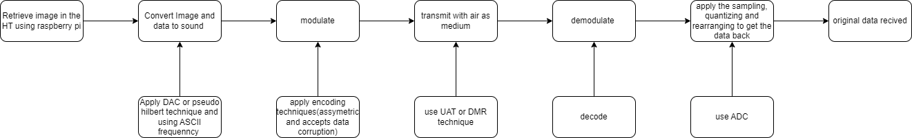

Figure 10- Block Diagram

- The working of the given proposition behaves in much a similar to the conventional networking and communication system.

- First the prototype device retrieves the image or text and converts them to acoustic form using either pseudo Hilbert technique or ascii frequency.

- That is for every pixel a particular frequency is provided using the the real part of the complex Hilbert transformation of the image.

- We use DAC(digital to analog) circuits to convert the digital signal(image or text) to analog signal(sound) , then the sound , is modulated and amplified using digital modulation techniques.

- While also encoding technique PGP is used to encrypt the data, such that it can handle lossless Transmission and accepts or handles data corruption,

- For different mediums different techniques are used liked UAT, then the demodulation and decryption circuits are applied, to get the desired output

Psuedo-Hilbert Technique:
Pseudo Hilbert curves are a type of space-filling curve that is based on the classic Hilbert curve. Space-filling curves are mathematical constructions that allow us to cover an infinite two-dimensional space with a finite curve. The original Hilbert curve is a well-known space-filling curve that is widely used in image compression, fractal analysis, and other mathematical applications.

Pseudo Hilbert curves are a modification of the Hilbert curve that are designed to improve its properties. The term "pseudo" refers to the fact that these curves are not true Hilbert curves, but rather an approximation of them. However, they still retain many of the useful properties of the Hilbert curve, such as the ability to traverse adjacent points in space in a sequential order.

Pseudo Hilbert curves are created by dividing a square into four quadrants and then recursively subdividing each quadrant into four smaller quadrants. At each level of recursion, the curve passes through each of the smaller quadrants in a predetermined order, which ensures that adjacent points are visited sequentially.

One of the key benefits of Pseudo Hilbert curves is their ability to provide efficient and compact indexing of multi-dimensional data. They can be used to map high-dimensional data onto a lower-dimensional space while preserving the ordering of the data points. This makes them useful for a variety of applications, such as data compression, image processing, and spatial data analysis.

Pseudo Hilbert curves also have the property of locality, meaning that nearby points in space tend to be mapped onto nearby points in the curve. This property makes them useful for indexing and searching data in large databases, as queries can be efficiently localized within the curve.

Overall, Pseudo Hilbert curves are a powerful mathematical tool that can be used to represent complex data in a compact and efficient manner. They offer many advantages over traditional data representations and are widely used in a variety of applications. Whether you are a mathematician, a computer scientist, or an engineer, Pseudo Hilbert curves are an important tool to have in your toolbox.

Converting ASCII data to frequencies:
Converting ASCII data into frequency values typically involves a two-step process: first, the ASCII data is transformed into numerical data, and then the numerical data is transformed into frequency values. Here is a general outline of the process:

- Transform the ASCII data into numerical data:

The ASCII data can be transformed into numerical data using an encoding scheme such as ASCII, Unicode, or UTF-8. Each character in the ASCII data is assigned a numerical value based on the encoding scheme used. For example, in the ASCII encoding scheme, the character 'A' is assigned the numerical value 65. This process is often performed using software libraries or built-in functions in programming languages such as Python or MATLAB.

- Transform the numerical data into frequency values:

Once the ASCII data has been transformed into numerical data, it can be further transformed into frequency values. This is typically done using a Fourier Transform, which is a mathematical technique that allows us to decompose a signal into its constituent frequencies. The Fourier Transform can be applied to the numerical data to obtain a frequency spectrum, which shows the amplitudes and phases of the different frequencies in the signal.

The frequency spectrum can then be further processed to extract specific frequency values of interest. For example, if you are interested in the dominant frequency in the signal, you can identify the peak frequency in the spectrum. Alternatively, if you are interested in the distribution of frequencies in the signal, you can calculate statistics such as the mean, standard deviation, or variance of the frequency spectrum.

In summary, converting ASCII data into frequency values involves transforming the ASCII data into numerical data using an encoding scheme, and then applying a Fourier Transform to the numerical data to obtain a frequency spectrum. The frequency spectrum can then be further processed to extract specific frequency values of interest.

The frequency spectrum can be analyzed to identify the frequency components of interest. For example, if we are analyzing speech data, we might be interested in the frequency components that correspond to different phonemes or sounds in the speech signal. Alternatively, if we are analyzing music data, we might be interested in the frequency components that correspond to different notes or chords in the music.

There are many applications for converting ASCII data into frequency values. In audio and speech processing, it is used for tasks such as speech recognition, speaker identification, and audio compression. In music processing, it is used for tasks such as music transcription, chord recognition, and genre classification. In general, it is a useful technique for analyzing any type of digital signal that contains frequency information.

Converting multimedia data to acoustic frequencies:
Pseudo Hilbert curves can be used to convert an image into frequencies by mapping the two-dimensional spatial information in the image to a one-dimensional curve, and then applying a Fourier Transform to the resulting curve to obtain the frequency components of the image. Here are the basic steps for using a Pseudo Hilbert curve to convert an image to frequencies:

1. Choose a Pseudo Hilbert curve: There are different types of Pseudo Hilbert curves, each with its own properties and trade-offs. Choose a curve that is suitable for your application, based on factors such as curve length, number of iterations, and continuity of the curve.

2. Map the image to the curve: Each pixel in the image is mapped to a point on the curve, by traversing the curve in a manner that preserves the spatial relationships between the pixels. This can be done using a variety of algorithms, such as the Gray code or the Hilbert scan algorithm. The resulting sequence of points on the curve represents the image in a one-dimensional format.

3. Apply a Fourier Transform to the curve: The one-dimensional sequence of points on the curve can be transformed into frequency components using a Fourier Transform. The Fourier Transform converts the spatial information in the curve to frequency information, by representing the curve as a sum of sine and cosine functions of different frequencies.

4. Analyze the frequency spectrum: The resulting frequency spectrum shows the amplitude and phase of the different frequency components of the image. The frequency components can be analyzed to identify patterns or features in the image that are of interest, such as edges, textures, or shapes.

5. Optionally, transform the frequency spectrum back to an image: The frequency spectrum can be transformed back to an image format, by applying an inverse Fourier Transform. This can be useful for visualizing the frequency components of the image, or for processing the image in the frequency domain.

In summary, using a Pseudo Hilbert curve to convert an image to frequencies involves mapping the image to a one-dimensional curve, applying a Fourier Transform to the curve to obtain the frequency spectrum, and analyzing the frequency spectrum to identify patterns or features in the image. This technique has many applications in image processing and computer vision, such as image compression, feature extraction, and pattern recognition.

To convert frequencies obtained from digital signal processing to acoustic frequencies that can be heard by the human ear, we need to convert the digital frequency values to their corresponding physical frequency values, which are measured in Hertz (Hz).

The relationship between digital frequency values and physical frequency values depends on the sampling rate of the digital signal. The sampling rate is the number of samples taken per second, and it is usually expressed in Hertz. For example, if the sampling rate is 44100 Hz, it means that 44100 samples are taken per second.

To convert digital frequency values to physical frequency values, we can use the following formula:

physical frequency = digital frequency * (sampling rate / 2)

The factor of 2 in the denominator is due to the Nyquist-Shannon sampling theorem, which states that the highest frequency that can be represented in a digital signal is half the sampling rate.

For example, suppose we have a digital frequency value of 1000 and a sampling rate of 44100 Hz. Using the formula above, we can calculate the corresponding physical frequency as:

physical frequency = 1000 * (44100 / 2) = 22.05 kHz

This means that the digital frequency of 1000 corresponds to a physical frequency of 22.05 kHz, which is in the range of frequencies that can be heard by most humans.

In summary, to convert digital frequency values to acoustic frequencies, we need to use the formula physical frequency = digital frequency * (sampling rate / 2), where the sampling rate is the number of samples taken per second, and then use the resulting physical frequency to generate an acoustic signal that can be heard by the human ear

Transmitting the frequencies over different mediums:
- AIR

To transmit sound over long distances without corrupting the data, there are several techniques that can be used to ensure the integrity of the signal. Here are some of the most common methods:

1. Error detection and correction: One of the most effective ways to ensure the integrity of transmitted sound data is to use error detection and correction techniques. These techniques can detect and correct errors that occur during transmission, such as noise, interference, or data corruption. Popular error detection and correction techniques include cyclic redundancy check (CRC), forward error correction (FEC), and error correction codes (ECC).

2. Signal amplification: To prevent signal loss over long distances, it may be necessary to use signal amplifiers to boost the strength of the signal. Signal amplifiers can be used at regular intervals along the transmission path to maintain the signal strength and reduce the effects of attenuation.

3. Frequency modulation: Frequency modulation (FM) is a technique for encoding sound data into an electromagnetic signal that can be transmitted over long distances. In FM, the frequency of the carrier signal is modulated by the sound data, resulting in a signal that can be easily transmitted over long distances without significant loss of data.

4. Compression techniques: To reduce the amount of data that needs to be transmitted, compression techniques can be used to compress the sound data into a smaller size. Popular compression techniques include MPEG, MP3, and AAC.

5. Encryption: To ensure the security and privacy of transmitted sound data, encryption techniques can be used to encrypt the data before transmission. This can prevent unauthorized access to the data and protect it from interception or tampering.

In summary, to transmit sound over long distances without corrupting the data, it is important to use error detection and correction techniques, signal amplification, frequency modulation, compression techniques, and encryption. These techniques can help to maintain the integrity of the sound data and ensure that it is transmitted accurately and securely over long distances.

- Water :

1. Acoustic waveguides: Acoustic waveguides are structures that can be used to direct and focus acoustic energy over long distances. These waveguides are often made of materials such as metal or plastic and can be designed to minimize the loss of energy over long distances.

2. Underwater acoustic communication: Underwater acoustic communication is a specialized method of transmitting acoustic data over long distances underwater. This technique can be used in applications such as underwater exploration, oceanography, and naval communication.

3. Seismic waves: Seismic waves are vibrations that are produced by earthquakes, explosions, and other disturbances in the earth's crust. These waves can be used to transmit acoustic data over long distances through the earth's crust, allowing for communication between remote locations.

4. Vibrational energy transfer: Vibrational energy transfer is a technique for transmitting acoustic energy over long distances using solid materials. This technique involves coupling a transducer to a solid material and using the material to transmit acoustic energy over long distances.

5. Acoustic telegraphy: Acoustic telegraphy is a method of transmitting coded messages over long distances using acoustic signals. This technique was used in the early days of communication and involves using specialized equipment to produce and receive acoustic signals.

6. Optical communication: Optical communication is a method of transmitting acoustic data over long distances using light waves. This technique involves using specialized equipment to convert acoustic signals into light waves, which can then be transmitted over fiber optic cables.

7. Airborne acoustic communication: Airborne acoustic communication is a method of transmitting acoustic data over long distances using sound waves in the air. This technique is often used in military applications, such as remote surveillance and reconnaissance.

8. Infrasonic communication: Infrasonic communication is a method of transmitting acoustic data over long distances using low-frequency sound waves. This technique can be used to transmit acoustic data over large distances through the atmosphere, making it useful in applications such as seismic monitoring and long-range communication.

9. Satellite communication: Satellite communication is a method of transmitting acoustic data over long distances using specialized satellites in orbit around the earth. This technique is often used in remote areas where other forms of communication are not available.

10. Acoustic delay lines: Acoustic delay lines are specialized devices that can be used to delay and filter acoustic signals. These devices can be used to transmit acoustic data over long distances by passing the signal through a series of delay lines, which can be located at different points along the transmission path.

11. Acoustic resonance: Acoustic resonance is a method of transmitting acoustic data over long distances by using the natural resonant frequencies of a medium. By carefully selecting the frequency of the transmitted signal, it is possible to create resonant vibrations in the medium that can be detected at a remote location.

12. Piezoelectric transducers: Piezoelectric transducers are devices that can convert acoustic energy into electrical energy, and vice versa. By coupling a piezoelectric transducer to a medium, it is possible to transmit acoustic data over long distances by converting the acoustic signal into an electrical signal that can be transmitted using wires or other forms of electrical communication.

13. Acoustic reflectors: Acoustic reflectors are specialized devices that can be used to reflect and focus acoustic energy over long distances. By carefully designing the shape and placement of these devices, it is possible to create a system that can transmit acoustic data over long distances with minimal loss of energy.

14. Directed acoustics: Directed acoustics is a technique for transmitting acoustic data over long distances by using highly focused acoustic beams. By carefully controlling the direction and intensity of these beams, it is possible to transmit acoustic data over long distances with minimal loss of energy.

15. Acoustic metamaterials: Acoustic metamaterials are materials that have been designed to exhibit unique acoustic properties. By carefully designing the structure and composition of these materials, it is possible to create systems that can transmit and manipulate acoustic energy over long distances in novel ways.

16. Underwater acoustic communication: Underwater acoustic communication is a method of transmitting acoustic data over long distances using sound waves in water. This technique is often used in marine research and exploration, underwater navigation, and offshore oil and gas exploration.

17. Acoustic telemetry: Acoustic telemetry is a method of transmitting acoustic data over long distances by embedding sensors in animals or other objects and then tracking them using specialized acoustic receivers. This technique is often used in marine biology, wildlife research, and military applications.

18. Acoustic cavitation: Acoustic cavitation is a method of transmitting acoustic data over long distances by creating tiny bubbles in a medium and then using the bubbles to transmit the signal. This technique is often used in medical applications, such as targeted drug delivery and non-invasive surgery.

19. Acoustic levitation: Acoustic levitation is a method of transmitting acoustic data over long distances by using sound waves to levitate objects in a medium. By carefully controlling the frequency and intensity of the sound waves, it is possible to move the levitated objects and transmit acoustic data.

20. Sonic booms: Sonic booms are powerful shock waves that are created when an object moves faster than the speed of sound. While sonic booms are often seen as a nuisance, they can also be used to transmit acoustic data over long distances by carefully controlling the frequency and intensity of the shock waves.

5.2 EXPECTED OUTCOME

- Our first outcome will be converting image into sound waves that is suitable for transmission using different encryption and modulation techniques.

- These images which are converted into sound for transmission will be non-detectable to sensors.

- Network sniffing and packet tracing of data from unauthorized users will be avoided to ensure the secure transmission of data.

5.3 APPLICATIONS

- The project provides a great deal of alternatives to current internet and RF comms, from calling 911 in a low signal strength area, to sharing data such as text, images, videos, without delay in low power conditions.

- The W.A.D.I.TO.H infrastructure can be used for a zero-infrastructure setup of non-contact payments using just a way file and microphone which is embedded in all devices nowadays, including devices which don't connect to either RF or internet.

- It has immense military application from underwater image transmission to data transmission over handheld transceivers in extreme terrains without any radio or internet setups, this can be also carry forwarded to local authority agencies.

- The other application in military is maintaining an end-to-end geolocation mapping of all personals, while also detecting any foreign object like people or obstacles.

- The concept of chirping' and listening' has enabled a system for hotel-user authentication, it has also been enabled for any confirmation process like people boarding buses in metropolitan cities.

CHAPTER 6

CONCLUSION

In this project, the data which will be in the form of audio or image that will be converted into sound waves for transmission over the destination regardless of any habitat or climatic condition or any environmental condition .We will be preventing data to be accessed by the unauthorized users i.e network sniffing and packet tracing .This data will again be converted back from sound to image or audio (depending on the senders data ).

REFERENCES

[1] Qasem, Z.A. Esmael, H Sun, H.; Wang, J.; Mian, Y: Anwar, 5. Enhanced fully
generalized spatial modulation for the internet of underwater things.

[2] Pearlman, WA. A new fast, and efficient image codec based on set partitioning in
hierarchical trees. IEEE Trans. Circuits Syst. Video Technol. 1996

[3] Teganathan, J, Ghrayeb, A.; Szczecinski, L. Generalized space shift keying modulation for MIMO channels. In Proceedings of the 19th International Symposium on Personal Indoor and Mobile Radio Communications, Cannes, France, 15-18 September 2008

[4] Mandal. A., Lopes, C.V., Givargis, T., Haghighit, A., Judah, R., Baldi, P., Beep: 3D
indoor positioning using audible sound. Consumer Communications and Networking
Conference, 2005

[5] William H. Press, Saul A. Teukolsky, William T. Vetterling, Brian P. Flannery.. Numerical
Recipes in C: The Art of Scientific Computing, Cambridge University Press New York
NY, USA, 1992

[6] Madhavapeddy, A.. Sharp, R., Scott, D., The, A... Audio networking: the forgotten wireless technology, Pervasive Computing. IEEE

